325 West 1100 South
Brigham City, UT 84302
435-237-2001

Client Intake Form
Name: Date of Birth:
Address: City/State/Zip:
Phone number: Email:
Would you like to be on an email list for promotions and appointment availability? ☐Yes ☐No
Occupation:
Emergency Contact: Relationship: Number:
How did you hear about us?

The following information will be used to help plan safe and effective massage sessions. Please answer the questions to the best of your knowledge.
Have you had a massage before? ☐Yes ☐No
Are you allergic to latex, lanolin, analgesic balms, essential oils, other?
Do you have any difficulty lying on your front, back, or side? ☐Yes ☐No
If yes, please explain:
Do you have any of the following: ☐Pins, Plates, or Screws ☐Surgical Implants
If so, where:
Are you wearing: ☐Contact lenses ☐Dentures ☐Hearing Aid
What are your goals for this treatment? (i.e., pain relief, relaxation, etc.)
Medical History
In order to plan a safe and effective massage session, I need some general information about your medical history.
Any previous/current broken bones or traumatic accidents?
Have you had any recent surgeries?
Please list any medications or supplements that you are taking.

Health History
Please select any past or current health conditions you may have:
☐ Allergies ☐ Edema/Swelling ☐ Tension/Stress ☐ Scoliosis
☐ Sleep Difficulties ☐ Whiplash ☐ Chronic Pain ☐ Sinus Issues
☐ Headaches, Migraines ☐ Cancer ☐ Pinched Nerve ☐Digestive Issues/IBS
☐ Numbness/Tingling ☐ Epilepsy/Seizures ☐ Cardiovascular Issues ☐ High Blood Pressure
☐ Stroke ☐ Sciatica ☐ Jaw Pain (TMJ) ☐ Bursitis
☐ Bone or Joint Disease ☐ Varicose Veins ☐ Depression/Anxiety ☐ Arthritis
Any other medical condition(s) not listed:

When you meet with your student therapist, painful areas will be marked with an X
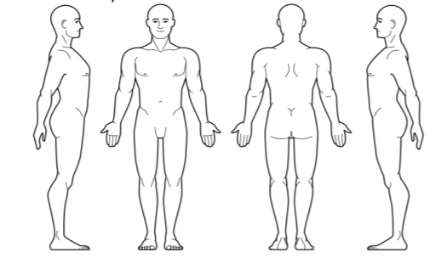
If indicated, please explain any spots I should be aware of:
At the time of your appointment, your body temperature will be recorded below
Client’s Temperature: Therapist’s Temperature:
INFORMED CONSENT: The above information is accurate to the best of my knowledge and I freely give my permission to be massaged. I agree to inform the therapist of any experience of pain during the session. I understand that bodywork should not be used as a substitute for medical examination, diagnoses, or treatment and I should consult the appropriate health care provider for mental or physical ailments. I understand that no inappropriate comments or conduct will be tolerated. Any indication of such behavior will automatically end the session.
Finally, I understand that all my information is confidential and released only with my written consent or as required by law.
Signed (the client): Date:
Student Therapist: Date:
Supervising Instructor: Date:

